Read Me First.

1. Go to IIS manager and add below two sites and map the virtual directories to build folders.

GBR.PlmOn and TenantManagement sites only.

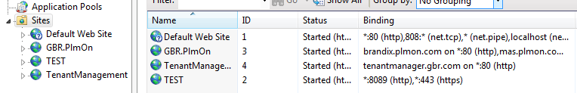

1. Edit binding for both sites should be like below.

On GBR.PlmOn

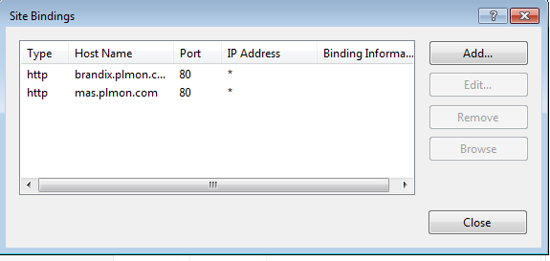

On TenentManagement

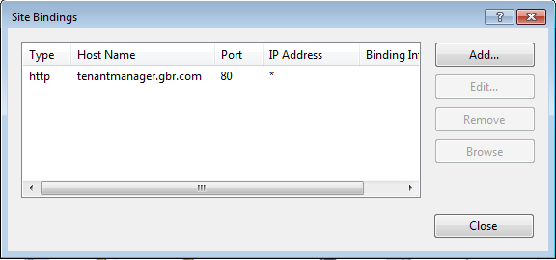

1. Update the Host file

"C:\Windows\System32\drivers\etc\hosts"

Open the Host file.

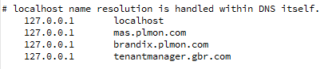

1. Restore GBRMetaData.bak.